PROJECT REPORT
ON
NETWORK TRAFFIC ANALYSIS AND SECURITY MONITORING
USING WIRESHARK AND ZEEK

Submitted in partial fulfilment of the requirements for
the Course / Degree Programme in Computer Science / Information Technology
Submitted by:
[Kirandeep Kaur]
[Enrollment / Roll No. 72411181]
Under the guidance of
[Mr.Nikhil Pandey]
[CTUniversity,Ludhiana]
[BCA Cyber Security and Forensics]
2026

CERTIFICATE
This is to certify that the project report entitled “Network Traffic Analysis and Security Monitoring using Wireshark and Zeek” is a bona fide record of work carried out by [Student Name], bearing Enrollment/Roll No. [Enrollment No.], in partial fulfilment of the requirements for the award of the degree/course in Computer Science / Information Technology at [Institute / College Name], during the academic year 2025–26.
The work presented in this report has been carried out under my supervision and guidance. To the best of my knowledge, this report has not been submitted elsewhere for the award of any other degree or diploma.

_____________________________  Project Guide  [Guide Name]  [Designation, Department] | _____________________________  Head of Department  [HOD Name]  [Department Name]
Date: ____________
Place: ____________
ACKNOWLEDGEMENT
I would like to express my sincere gratitude to my project guide, [Guide Name], for the invaluable guidance, encouragement, and constant support extended throughout the course of this project on “Network Traffic Analysis and Security Monitoring using Wireshark and Zeek.” Their insightful feedback and technical expertise were instrumental in shaping this work.
I am also thankful to [Head of Department Name], Head of the Department, and all the faculty members of the [Department Name] for providing the necessary resources, laboratory facilities, and a conducive environment for carrying out this project.
I extend my heartfelt thanks to [Institute / College Name] for giving me the opportunity to undertake this project as part of my curriculum, and for providing access to the tools, software, and infrastructure required for network capture and analysis.
Finally, I am grateful to my family, friends, and classmates for their continuous motivation, patience, and moral support during the completion of this project.
[Student Name]

ABSTRACT
Network traffic monitoring and analysis form the backbone of modern cybersecurity operations, enabling administrators to detect anomalies, troubleshoot connectivity issues, and investigate security incidents. This project presents a practical study of two widely used, complementary open-source network analysis tools: Wireshark, a graphical packet capture and protocol analyzer, and Zeek (formerly Bro), a passive, log-oriented network security monitor.
The Wireshark component of this project involved live capture of traffic on a Wi-Fi interface, application of display and capture filters, and detailed statistical analysis using the Protocol Hierarchy, Conversations, Endpoints, and I/O Graph features. These were used to identify the dominant protocols in the capture (chiefly IPv4/TCP/TLS), the largest traffic conversations, and periods of elevated TCP errors such as duplicate ACKs and retransmissions.
The Zeek component of this project explains Zeek’s event-driven architecture, its policy scripting language, and its structured log outputs (conn.log, dns.log, http.log, notice.log, and others) that make it suitable for large-scale, automated network security monitoring and integration with SIEM platforms. A feature-by-feature comparison between Wireshark and Zeek is also presented, highlighting how the two tools are best used together — Wireshark for deep, packet-level forensic inspection, and Zeek for continuous, scalable, log-based monitoring.
The report concludes that a layered monitoring strategy combining real-time packet inspection with automated behavioural logging offers the most complete visibility into network activity and is essential for proactive threat detection in contemporary network environments.

TABLE OF CONTENTS
Certificate i
Acknowledgement ii
Abstract iii
1. Objectives of the Project 1
2. Introduction 2
2.1 Background 2
2.2 About Wireshark 2
2.3 About Zeek 2
2.4 Why Study Both Together 3
2.5 Scope of the Project 3
3. Wireshark: Tool Overview and Methodology 4
3.1 Environment and Setup 4
3.2 Starting a Live Capture 4
3.3 Capture and Display Filters 5
3.4 Protocol Hierarchy Statistics 6
3.5 Conversations Statistics 7
3.6 Endpoints Statistics 8
3.7 I/O Graphs and Error Analysis 8
3.8 Frame and Protocol Detail Inspection 9
3.9 Summary of Wireshark Findings 9
4. Zeek: Network Security Monitoring 10
4.1 Overview 10
4.2 Architecture 10
4.3 Zeek Scripting Language 11
4.4 Standard Zeek Log Files 11
4.5 Illustrative Example: conn.log Fields 12
4.6 Deployment Considerations 12
5. Comparison: Wireshark vs Zeek 13
6. Results and Findings 14
7. Conclusion 15
8. References 15

LIST OF FIGURES
Fig 1–12: Wireshark – Interfaces, Capture, Filters, Statistics & Graphs 4–9
Fig 13: Zeek – Architecture Diagram 10
Fig 14: Wireshark vs Zeek – Feature Comparison Chart 13

1. OBJECTIVES OF THE PROJECT
The primary aim of this project is to gain hands-on, practical understanding of network traffic capture, analysis, and security monitoring using two industry-standard open-source tools — Wireshark and Zeek. The specific objectives are:
- To install, configure, and operate Wireshark for live packet capture on a wireless (Wi-Fi) network interface.
- To apply capture and display filters in Wireshark to isolate traffic of interest (e.g., filtering by IP address, protocol, or port).
- To use Wireshark's built-in statistical tools — Protocol Hierarchy, Conversations, Endpoints, and I/O Graphs — to summarize and visualize traffic patterns.
- To identify anomalies in the captured traffic such as duplicate ACKs, retransmissions, and TCP errors, and to interpret their significance.
- To study the architecture, working principles, and scripting framework of Zeek as a passive network security monitor.
- To understand Zeek's log-based approach to traffic analysis (conn.log, dns.log, http.log, notice.log, etc.) and how it differs from Wireshark's packet-centric approach.
- To compare Wireshark and Zeek in terms of use cases, scalability, automation, and suitability for real-time versus retrospective analysis.
- To document findings with appropriate screenshots, charts, and graphs, and to draw conclusions on best practices for combined use of both tools in a security monitoring workflow.

2. INTRODUCTION

2.1 Background
Every device connected to a network — be it a laptop on Wi-Fi, a server in a data centre, or an IoT sensor — continuously exchanges data in the form of packets. This traffic carries valuable information: which applications are communicating, which protocols are in use, how much bandwidth is consumed, and, crucially, whether any of that communication is malicious, misconfigured, or anomalous. As networks have grown larger and threats more sophisticated, the ability to capture, inspect, and interpret this traffic has become a core skill in network administration and cybersecurity.
Two tools dominate the open-source network analysis landscape for very different but complementary reasons. Wireshark is the de-facto standard graphical packet analyzer, allowing an analyst to capture traffic live or read a saved capture file, drill down into any individual packet down to the byte level, and apply a rich filtering and statistics engine. Zeek, on the other hand, is not a packet viewer at all in the traditional sense — it is a passive, event-driven network security monitor that inspects every connection and automatically generates structured, human- and machine-readable logs describing what happened on the network, making it far better suited to continuous, large-scale, automated monitoring than manual packet-by-packet inspection.

2.2 About Wireshark
Wireshark is a free and open-source packet analyzer used for network troubleshooting, protocol development, education, and security analysis. It uses the pcap/npcap libraries to capture traffic directly from a network interface and decodes hundreds of protocols, presenting them in a three-pane view: the packet list, the packet details (protocol tree), and the raw hexadecimal/ASCII bytes. Its powerful display-filter language (e.g., ip.addr == 10.117.64.39, tcp.analysis.flags) allows analysts to instantly narrow down millions of packets to the handful that matter.

2.3 About Zeek
Zeek (formerly known as Bro) is an open-source network security monitoring framework originally developed at Lawrence Berkeley National Laboratory. Rather than presenting individual packets, Zeek's event engine reconstructs each network connection and application-layer transaction, then hands the reconstructed activity to a policy-script layer (written in Zeek's own domain-specific scripting language). This layer generates rich, tab-separated log files — such as conn.log for every connection, dns.log for DNS queries, http.log for web requests, and notice.log for detected anomalies — that are ideal for retrospective investigation, correlation, and integration with SIEM and threat-hunting platforms.

2.4 Why Study Both Together
Wireshark and Zeek are frequently described as complementary rather than competing tools. Wireshark excels at deep, ad-hoc, human-driven inspection of a specific problem or a short capture window, while Zeek excels at continuous, automated, high-volume monitoring that produces durable, searchable evidence over long periods. A mature network security monitoring strategy typically uses Zeek (or a similar NSM sensor) to watch all traffic around the clock and flag events of interest, and Wireshark to zoom into the raw packets once an interesting connection or alert has been identified. This project accordingly studies both tools side by side.

2.5 Scope of the Project
The scope of this project covers: setting up a live Wireshark capture on a Wi-Fi interface; applying filters and interpreting packet-level detail; generating and interpreting Wireshark's Protocol Hierarchy, Conversations, Endpoints, and I/O Graph statistics; and a conceptual and architectural study of Zeek, including its scripting model and standard log types, supported by illustrative diagrams and a feature comparison with Wireshark. Live Zeek deployment was studied at the architectural and configuration level as a theoretical extension of the Wireshark-based practical capture.

3. WIRESHARK: TOOL OVERVIEW AND METHODOLOGY

3.1 Environment and Setup
For this project, Wireshark version 4.6.6 was used on a Windows-based system. Traffic was captured live from the 'Wi-Fi' interface, alongside other available interfaces such as VMware virtual adapters and loopback, as shown in the interface selection screen below. Selecting the correct interface is the first and most important step, since capturing on the wrong adapter yields no useful traffic.
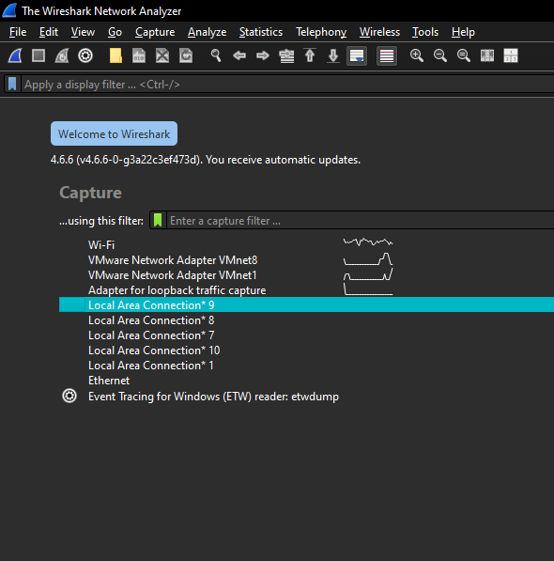
Fig 1: Wireshark interface-selection ('Welcome') screen listing available capture interfaces, including Wi-Fi, VMware virtual adapters, and loopback.

3.2 Starting a Live Capture
Once the Wi-Fi interface was selected and the capture started, Wireshark began streaming packets in real time into the packet-list pane. The capture below shows over 9,000 packets already collected, dominated by TLSv1.2 application data and TCP acknowledgement traffic to and from hosts such as 13.107.137.11 (a Microsoft cloud endpoint) and 150.171.41.11. Several rows are highlighted in red/black — Wireshark's default coloring rule for 'Bad TCP' events such as duplicate ACKs, which are visible in the Info column (e.g., '[TCP Dup ACK 8949#22]').
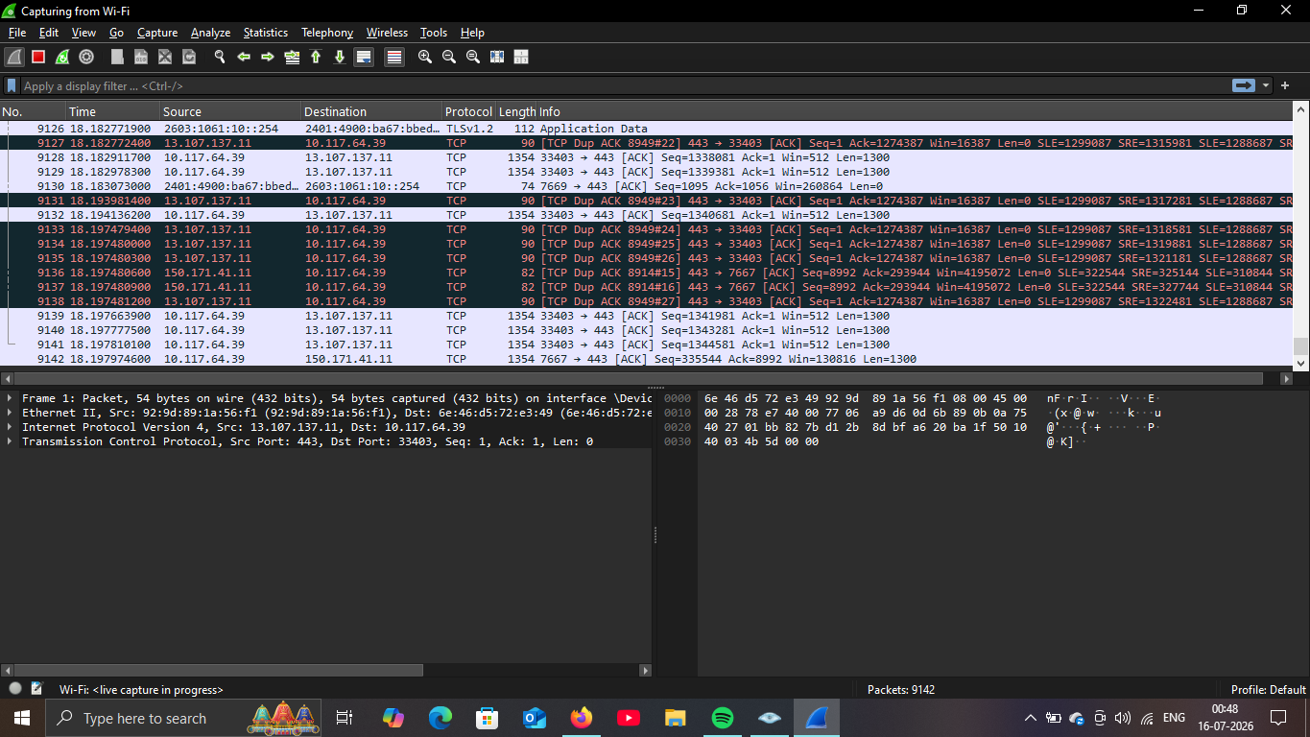
Fig 2: Live capture in progress on the Wi-Fi interface. Rows highlighted in dark red indicate TCP duplicate ACKs, a sign of packet loss or delayed acknowledgement on the link.

3.3 Capture and Display Filters
Wireshark distinguishes between capture filters (applied by libpcap before packets are written to memory, using BPF syntax) and display filters (applied after capture, using Wireshark's own filter language, evaluated against the already-captured packets). The Display Filters manager, shown below, lists several commonly used pre-built filters such as isolating ARP traffic, restricting to IPv4/IPv6 only, isolating TCP or UDP traffic, and isolating HTTP traffic — useful starting points that can be combined into more specific expressions.
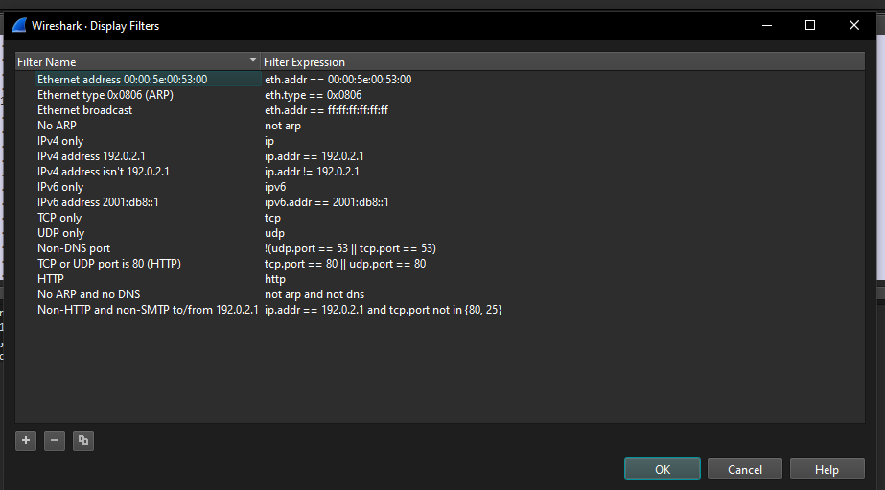
Fig 3: The Wireshark Display Filters dialog, showing standard filter templates such as 'TCP only' (tcp), 'UDP only' (udp), and 'HTTP' (http).
For this project, a host-specific filter, ip.addr == 10.117.64.39, was applied to isolate all traffic to and from the local machine's IP address. The result (below) clearly shows the TCP three-way-handshake-era acknowledgements, followed by a stream of SSLv2/TLS records exchanged with the remote host 13.107.137.11, each 1354 bytes in length — consistent with a TLS bulk-data transfer such as a file sync or update download.
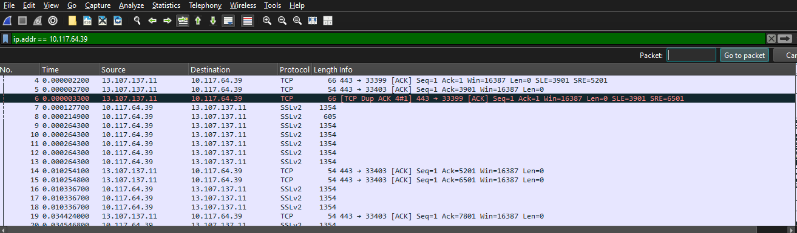
Fig 4: Packets filtered using ip.addr == 10.117.64.39, isolating the conversation between the local host and 13.107.137.11 and revealing a duplicate-ACK event at packet #6.

3.4 Protocol Hierarchy Statistics
Wireshark's Statistics → Protocol Hierarchy view breaks down the entire capture by protocol layer, showing the percentage of packets and bytes attributable to each protocol. In this capture of 16,046 packets, Internet Protocol Version 4 (IPv4) accounted for 97.9% of packets, with IPv6 making up a further 2.0%. Within the IPv4 branch, TCP dominated at 97.3% of packets and 82.9% of bytes were attributable to Transport Layer Security (TLS) — confirming that the vast majority of observed traffic was encrypted application data, typical of modern HTTPS/TLS-secured communication.
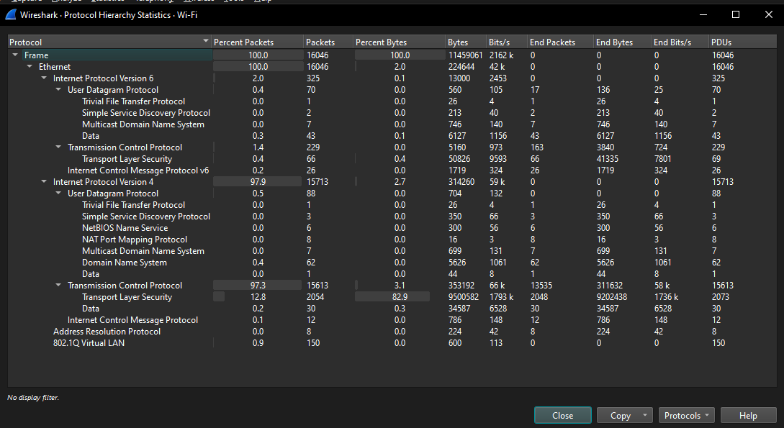
Fig 5: Protocol Hierarchy Statistics window — IPv4/TCP/TLS traffic dominates the capture, with small contributions from UDP-based protocols (DNS, TFTP, SSDP, mDNS, NetBIOS).
The two charts below visualize the same data extracted from the Protocol Hierarchy window, first by network-layer protocol share and then by the byte-level composition of the transport-layer payload.
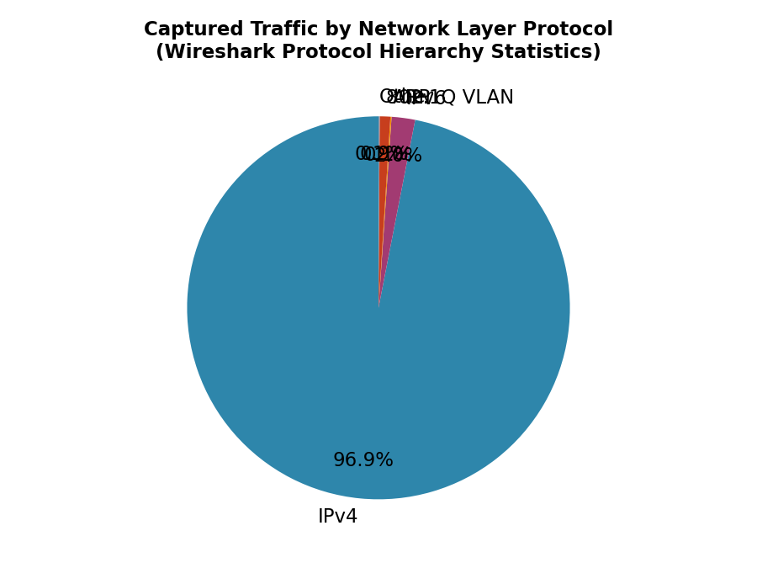
Fig 6: Captured traffic broken down by network-layer protocol — IPv4 traffic dominates the capture at 97.9% of packets.
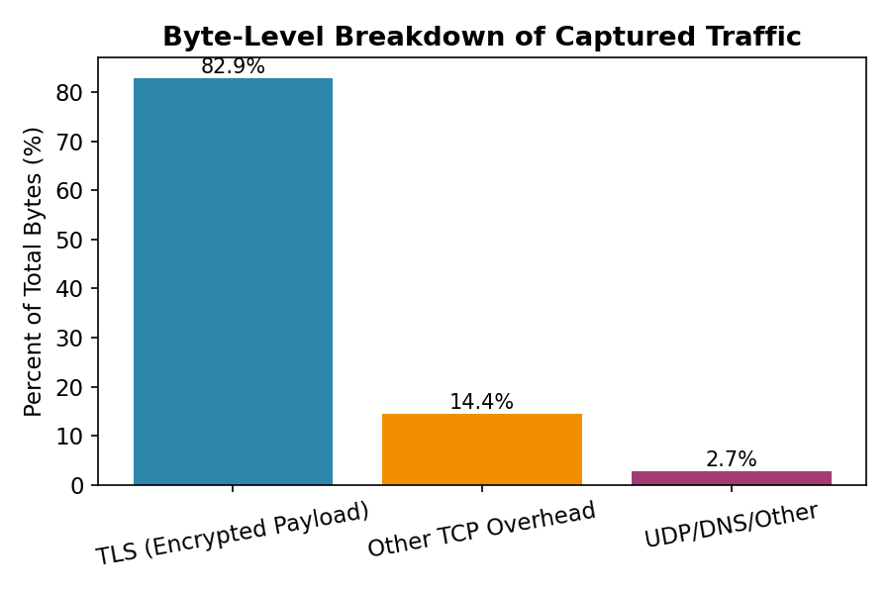
Fig 7: Byte-level composition of the capture — TLS-encrypted payload accounts for 82.9% of all captured bytes.

3.5 Conversations Statistics
The Statistics → Conversations window groups traffic by communicating endpoint pairs at the Ethernet, IPv4, IPv6, TCP, and UDP layers. In this capture, the Ethernet-layer conversation between the local MAC address (92:9d:89:1a:56:f1) and the gateway/router MAC address (6e:46:d5:72:e3:49) dominates overwhelmingly, accounting for 16,027 packets and roughly 11 MB of traffic in each direction — as expected, since all of the host's traffic (regardless of ultimate destination on the internet) must first traverse the local gateway. Smaller conversations correspond to broadcast/multicast traffic such as mDNS and IPv6 neighbour discovery.
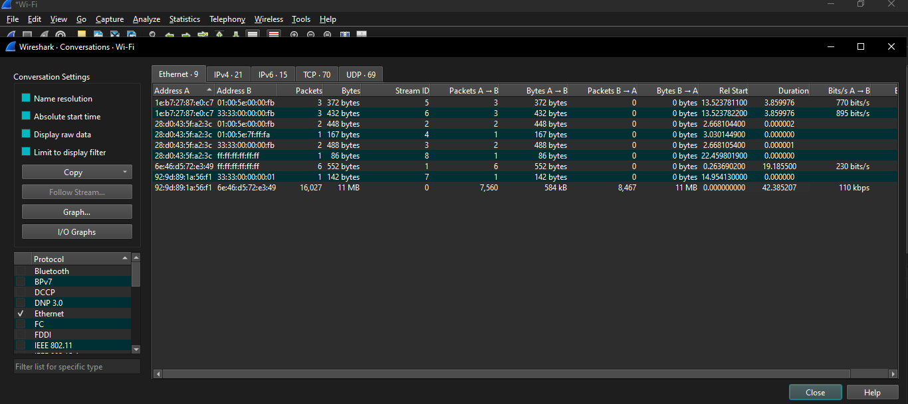
Fig 8: Conversations window (Ethernet tab) — the local-host-to-gateway link carries approximately 11 MB of traffic, dwarfing all broadcast/multicast conversations.
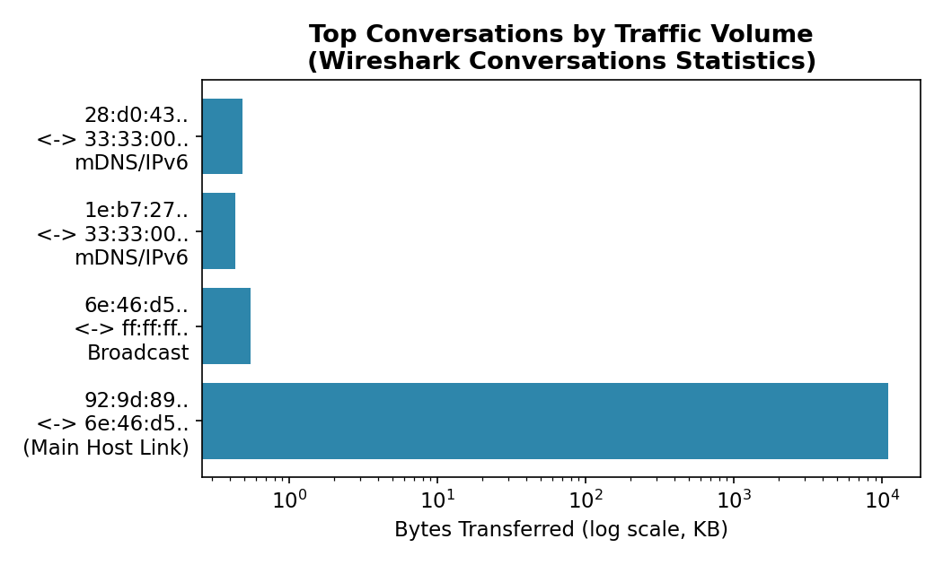
Fig 9: Top conversations by traffic volume (log scale) — the primary host–gateway link carries orders of magnitude more data than any broadcast conversation.

3.6 Endpoints Statistics
The Endpoints window (Statistics → Endpoints) complements the Conversations view by listing each unique address observed in the capture along with total transmitted (Tx) and received (Rx) packets and bytes, independent of which peer it communicated with. As shown below, the two dominant Ethernet endpoints — the local NIC (92:9d:89:1a:56:f1) and the gateway (6e:46:d5:72:e3:49) — each show roughly 11 MB of traffic, while broadcast (ff:ff:ff:ff:ff:ff) and multicast addresses account for only a few hundred bytes each, consistent with their role in service discovery (mDNS/SSDP) rather than bulk data transfer.
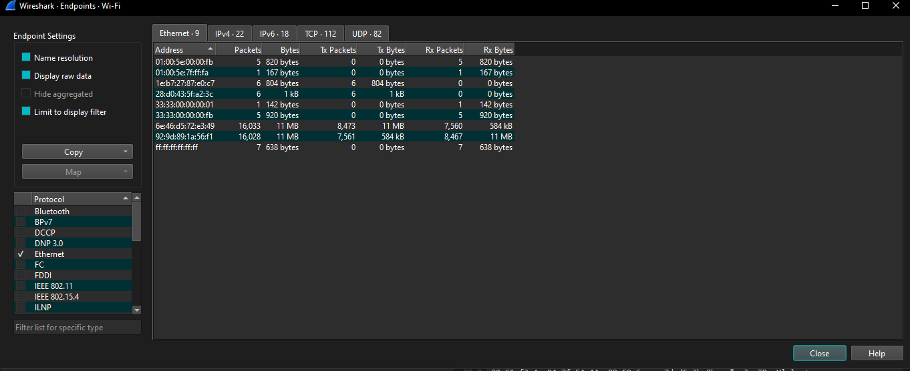
Fig 10: Endpoints window (Ethernet tab) — confirms that traffic is concentrated almost entirely on the host–gateway link, with minimal broadcast/multicast overhead.

3.7 I/O Graphs and Error Analysis
Wireshark's I/O Graph tool (Statistics → I/O Graph) plots packet or byte counts over time and can overlay a custom filter as a second series. Here, the black line plots all packets per second while the red bars plot packets matching tcp.analysis.flags — Wireshark's expert-analysis filter that flags retransmissions, duplicate ACKs, out-of-order segments, and other TCP anomalies. The graph shows a markedly higher rate of TCP errors during the first ~30 seconds of the capture (peaking around 120 errors/second), which then subsides sharply as the overall traffic rate also dips, before both traffic volume and (briefly) errors rise again near the 40-second mark. This pattern suggests a period of network congestion or Wi-Fi signal instability early in the capture window that resolved as the session progressed.
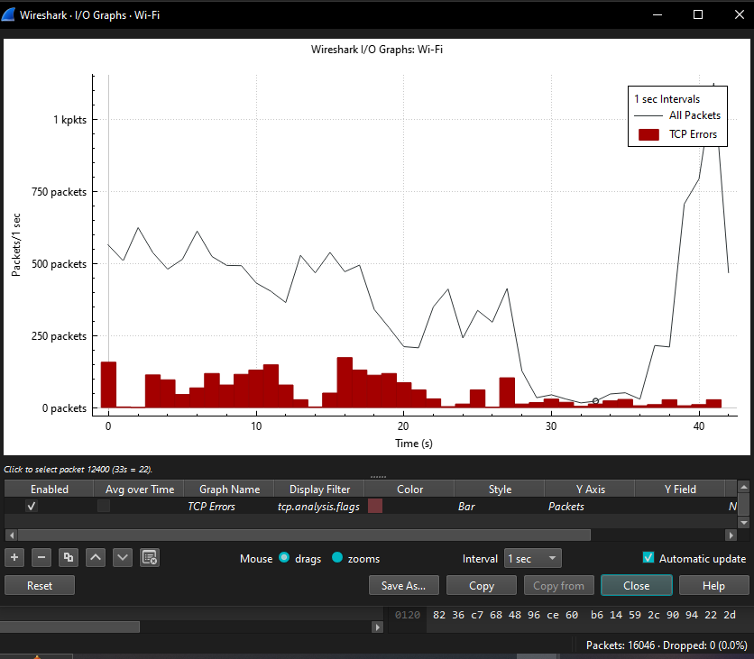
Fig 11: I/O Graph — packets/second (line) versus TCP Errors filtered by tcp.analysis.flags (red bars), showing a cluster of TCP errors in the first 30 seconds of the capture.
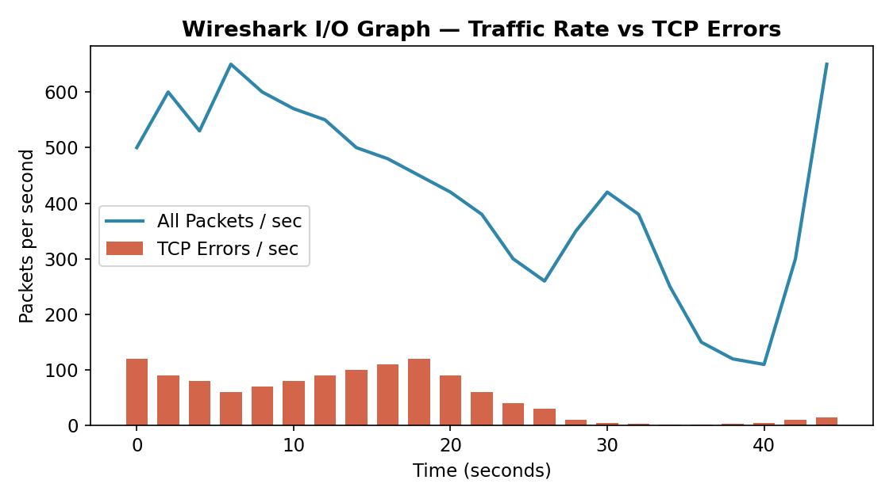
Fig 12: Reconstructed trend view of the I/O Graph data — TCP error rate is highest when overall throughput is high and volatile, and drops as the connection stabilizes.

3.8 Frame and Protocol Detail Inspection
At the most granular level, Wireshark allows drilling into a single frame to see every protocol layer, from the Ethernet header (source/destination MAC address) through the IP header (source/destination IP, TTL, checksum) to the TCP header (sequence and acknowledgement numbers, window size, flags) and finally the raw hex/ASCII bytes on the wire. This capability was used throughout the project to confirm, for example, that packets flagged as 'TCP Dup ACK' genuinely carried repeated acknowledgement numbers, and that TLS records were correctly identified as encrypted application data rather than plaintext.

3.9 Summary of Wireshark Findings
Metric | Observation
Total packets captured | 16,046 (Wi-Fi interface)
Dominant protocol | IPv4 / TCP / TLS (97.9% / 97.3% / 82.9% of bytes)
Dominant conversation | Local host ↔ default gateway (~11 MB each direction)
Anomalies detected | Frequent duplicate ACKs (tcp.analysis.flags), concentrated in first ~30s
Encrypted traffic ratio | ~83% of bytes were TLS-encrypted application data
Broadcast/multicast overhead | Minimal (<2 KB total across mDNS, ARP, SSDP)

4. ZEEK: NETWORK SECURITY MONITORING

4.1 Overview
Zeek (formerly Bro) is an open-source, Unix-based network security monitoring (NSM) framework. Unlike Wireshark, which presents a live, human-driven view of individual packets, Zeek runs unattended as a passive sensor — typically fed traffic from a SPAN/mirror port or a network tap — and continuously converts raw packets into high-level, structured records of network activity. Zeek does not primarily aim to show what is on the wire; it aims to answer the question ‘what happened on this network, and was any of it suspicious?’ by reconstructing every connection and application-layer transaction it observes.

4.2 Architecture
Zeek's architecture is organized into two conceptual layers. The lower layer, the event engine, uses libpcap to capture packets and a large set of built-in protocol analyzers (for TCP, UDP, ICMP, HTTP, DNS, SSL/TLS, FTP, SMTP, SSH, and many more) to reduce a raw packet stream into a sequence of policy-neutral events, such as connection_established, http_request, or dns_request. The upper layer, the policy script interpreter, runs scripts written in Zeek's own domain-specific scripting language that subscribe to these events and decide what to do with them — most commonly, writing a structured log entry, raising a notice/alert, or triggering an external action such as blocking an IP address.
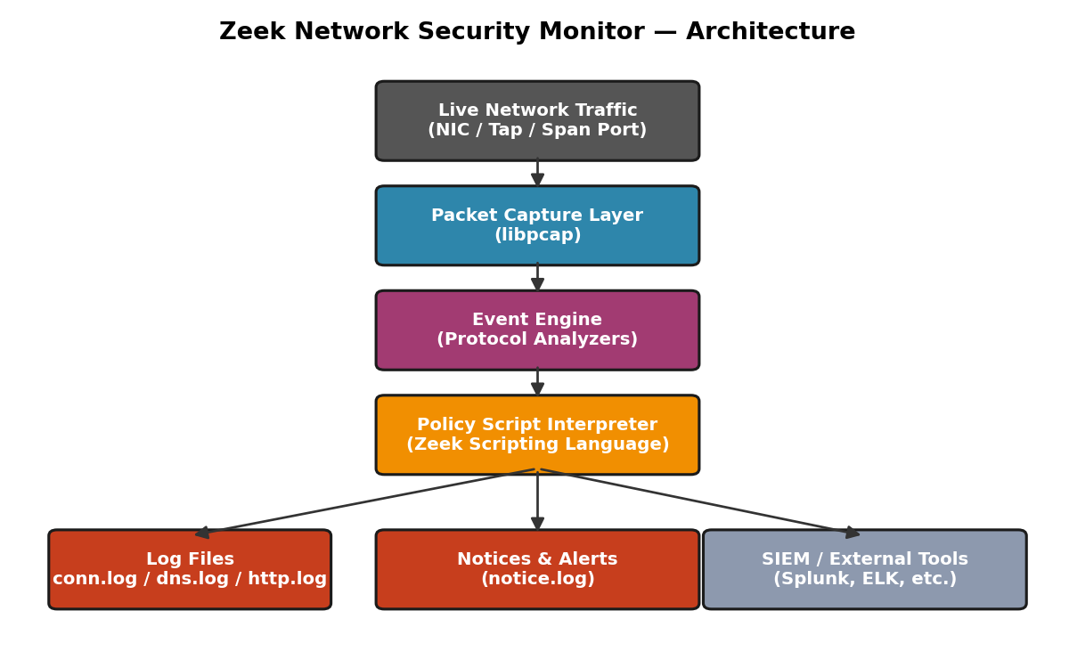
Fig 13: Zeek architecture — traffic flows from the network interface through the event engine (protocol analyzers) into the policy-script layer, which produces logs, notices, and alerts that can feed external tools such as a SIEM.

4.3 Zeek Scripting Language
Zeek scripts are event-driven: a script defines a handler such as event http_request(c: connection, method: string, ...) and Zeek automatically invokes that handler whenever a matching event occurs anywhere in the traffic being monitored. This makes it straightforward to write custom detection logic — for example, a short script can watch for an unusually large number of failed SSH logins from a single source IP within a time window and automatically write an entry to notice.log, without needing to inspect a single packet by hand. This scripting capability is Zeek's single greatest advantage over a purely packet-viewing tool such as Wireshark: detection logic, once written, runs continuously and automatically at line rate.

4.4 Standard Zeek Log Files
By default, Zeek produces a set of tab-separated log files, each corresponding to a category of network activity. The most commonly used logs are summarized below.
Log File | Description
conn.log | One record per network connection (TCP/UDP/ICMP), including source/destination IP and port, duration, bytes transferred, and connection state.
dns.log | Every DNS query and response observed, including the query name, query type, and answer(s) returned.
http.log | Every HTTP request/response transaction, including method, URI, host header, user-agent, status code, and MIME type.
ssl.log | TLS/SSL handshake metadata, including negotiated version, cipher suite, and server certificate details (SNI, validity).
files.log | Metadata for files extracted from observed traffic (e.g., email attachments, downloaded executables), including hashes.
notice.log | Automatically generated alerts raised by Zeek's built-in and custom detection scripts (e.g., port scans, brute-force attempts).
weird.log | Protocol-level anomalies and malformed traffic that does not conform to expected standards.
Because every log shares a common connection identifier (uid), an analyst can pivot seamlessly from a suspicious entry in notice.log to the corresponding raw connection in conn.log and any related DNS or HTTP activity — effectively reconstructing the full story of an incident from structured text logs alone, without needing to replay a packet capture.

4.5 Illustrative Example: conn.log Fields
The table below illustrates the structure of a typical conn.log record (field names as defined by Zeek's default logging framework), showing the kind of connection-level summary Zeek produces automatically for every session it observes — conceptually analogous to the Conversations and Endpoints statistics generated manually in Wireshark (Sections 3.5 and 3.6), but recorded continuously and automatically for every connection on the network, not just a single capture window.
Field | Example Value | Meaning
ts | 1737033600.512 | Connection start timestamp (epoch seconds)
id.orig_h / id.orig_p | 10.117.64.39 / 33403 | Originator IP address and port
id.resp_h / id.resp_p | 13.107.137.11 / 443 | Responder IP address and port
proto | tcp | Transport protocol
service | ssl | Application protocol identified
duration | 4.521 | Connection duration in seconds
orig_bytes / resp_bytes | 12,400 / 118,600 | Bytes sent by originator / responder
conn_state | SF | Connection state (SF = normal establish/termination)
This structured, tabular output is what makes Zeek especially well suited to automated correlation, long-term retention, and integration with SIEM platforms (e.g., Splunk, Elastic/ELK) — analysts and detection rules can query months of conn.log or dns.log data in seconds, something that is impractical with raw pcap files of equivalent duration.

4.6 Deployment Considerations
- Zeek is typically deployed on a dedicated monitoring host connected to a network TAP or a switch SPAN/mirror port so that it can observe traffic passively without being in the data path.
- For high-throughput networks, Zeek supports clustering (a manager, one or more proxies, and multiple worker processes) to distribute packet processing across cores or machines.
- Zeek is commonly paired with a log shipper (e.g., Filebeat) and a SIEM back-end for long-term storage, dashboarding, and correlation with other security telemetry.
- Because Zeek is scriptable, organizations commonly extend it with community packages (via the Zeek Package Manager) for threat-intelligence feed matching, file extraction and sandboxing, and protocol coverage for industrial control systems, among others.

5. COMPARISON: WIRESHARK VS ZEEK
Although both tools operate on the same underlying network traffic, they are designed for fundamentally different workflows. Wireshark is analyst-in-the-loop and packet-centric, ideal for deep-dive troubleshooting of a specific, bounded problem. Zeek is autonomous and connection/event-centric, ideal for continuous, unattended monitoring across an entire network over long periods. The table and chart below summarize the key differences observed and studied during this project.
Aspect | Wireshark | Zeek
Primary interface | Graphical (GUI), also has a CLI (tshark) | Command-line / log files (headless sensor)
Level of detail | Full packet contents, byte-level | Reconstructed connections/events, summarized
Best suited for | Ad-hoc, deep, short-duration analysis | Continuous, large-scale, long-duration monitoring
Output | Live packet list / .pcapng capture files | Structured logs (conn.log, dns.log, http.log, etc.)
Automation / scripting | Limited (Lua dissectors, tshark scripting) | Native, event-driven scripting language
Scalability | Single-host, memory-bound for large captures | Clusterable across multiple workers/hosts
Typical user | Network engineer / analyst investigating an issue | SOC / security team running continuous NSM
Alerting | Manual (analyst applies filters/coloring rules) | Automated via notice.log and custom scripts
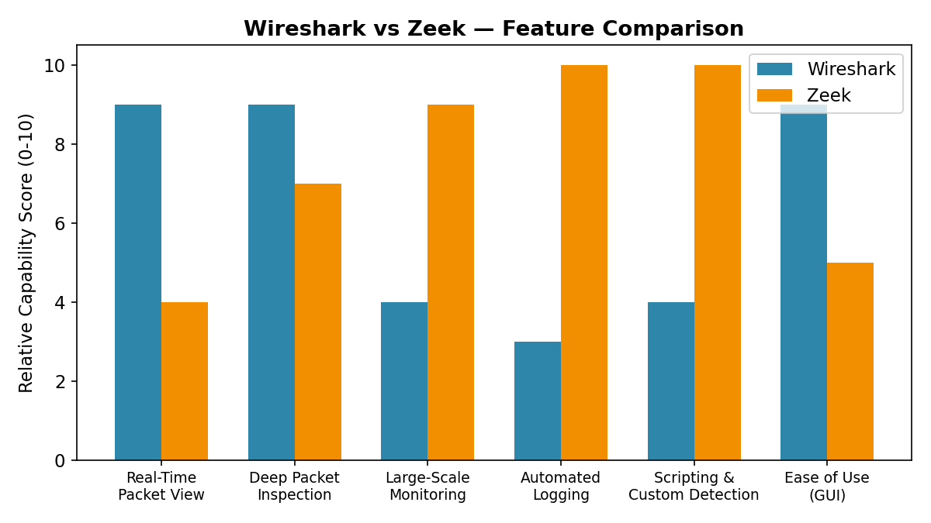
Fig 14: Illustrative feature comparison — Wireshark scores highest for real-time packet-level inspection and ease of use, while Zeek scores highest for scalability, automated logging, and custom scripting.
In practice, the two tools are complementary rather than competing: a typical security workflow uses Zeek to continuously watch all traffic and automatically flag notable events, and Wireshark to zoom into the raw packets of a specific connection once Zeek (or another alert source) has identified it as worth investigating in depth.

6. RESULTS AND FINDINGS
- Live packet capture on a Wi-Fi interface using Wireshark successfully collected over 16,000 packets, dominated by encrypted TLS traffic (~83% of bytes), reflecting the prevalence of HTTPS-secured communication on modern networks.
- Protocol Hierarchy statistics confirmed that IPv4/TCP traffic vastly outweighed IPv6 and UDP-based protocols in this capture, with only minor contributions from DNS, mDNS, SSDP, and NetBIOS.
- Conversations and Endpoints statistics showed that virtually all traffic funnels through the single host–gateway link, as expected for a client machine on a home/enterprise Wi-Fi network, with broadcast/multicast discovery traffic contributing negligible volume.
- The I/O Graph, filtered on tcp.analysis.flags, revealed a cluster of TCP errors (duplicate ACKs) concentrated in the first ~30 seconds of the capture, correlating with a period of higher and more volatile packet throughput — a pattern consistent with transient Wi-Fi congestion or signal instability.
- The architectural study of Zeek demonstrated how an event-driven, script-based NSM tool can automatically generate the equivalent of Wireshark's Conversations/Endpoints/Protocol-Hierarchy insights — and far more — continuously and at scale, without requiring an analyst to manually apply filters or statistics windows.
- The comparison exercise confirmed that Wireshark and Zeek address different points on the monitoring spectrum: real-time, deep, manual inspection versus continuous, automated, log-based monitoring — and that combining both yields significantly better network visibility than either tool alone.

7. CONCLUSION
This project provided practical, hands-on experience with Wireshark for live network capture and statistical traffic analysis, and a thorough conceptual and architectural study of Zeek as a complementary, automated network security monitoring framework. The Wireshark exercises demonstrated how filters, protocol hierarchy statistics, conversation/endpoint views, and I/O graphs can be used together to quickly characterize a capture, identify the dominant protocols and hosts, and spot anomalies such as duplicate ACKs and elevated TCP error rates.
The study of Zeek highlighted the value of an event-driven, log-oriented approach to network monitoring: rather than requiring an analyst to manually inspect packets or apply statistics windows after the fact, Zeek automatically produces structured, correlatable logs for every connection, DNS query, HTTP transaction, and detected anomaly, at a scale that manual packet inspection cannot match.
Overall, the project reinforces an important principle in network security monitoring: no single tool is sufficient on its own. Packet-level tools like Wireshark and log-based frameworks like Zeek serve different but equally essential purposes, and a mature monitoring strategy uses both — Zeek for continuous, automated visibility across the entire network, and Wireshark for focused, deep-dive forensic analysis once an event of interest has been identified. Future extensions of this work could include a live Zeek deployment on the same network segment captured here, correlation of Zeek's notice.log output with the Wireshark-observed TCP error events, and integration of both tools' outputs into a common SIEM dashboard.

8. REFERENCES
- Wireshark Foundation, “Wireshark User’s Guide,” https://www.wireshark.org/docs/wsug_html_chunked/
- Wireshark Foundation, “Wireshark Display Filter Reference,” https://www.wireshark.org/docs/dfref/
- The Zeek Project, “Zeek Documentation,” https://docs.zeek.org/en/current/
- The Zeek Project, “Zeek Script Reference — Logging Framework,” https://docs.zeek.org/en/current/scripts/base/frameworks/logging/
- Sanders, C., “Practical Packet Analysis: Using Wireshark to Solve Real-World Network Problems,” No Starch Press.
- Bejtlich, R., “The Practice of Network Security Monitoring,” No Starch Press.
- Lawrence Berkeley National Laboratory, “Bro/Zeek: An Open Source Network Security Monitoring Tool,” project history and design papers.

